HTML Quotation and Citation Elements

📘 Definition
# Source: AI Source: Provided by: [Data Path: Persons Table -> ID Column: 1, Name_En Column: Motasem Essam] -> From: [ChatGPT] on [5/6/2026]
HTML quotation and citation elements are used to represent:
- quotes
- citations
- references
- abbreviations
- addresses
- titles of works
They help give text meaning and structure.

🔤 Common Quotation & Citation Elements
# Source: AI Source: Provided by: [Data Path: Persons Table -> ID Column: 1, Name_En Column: Motasem Essam] -> From: [ChatGPT] on [5/6/2026]
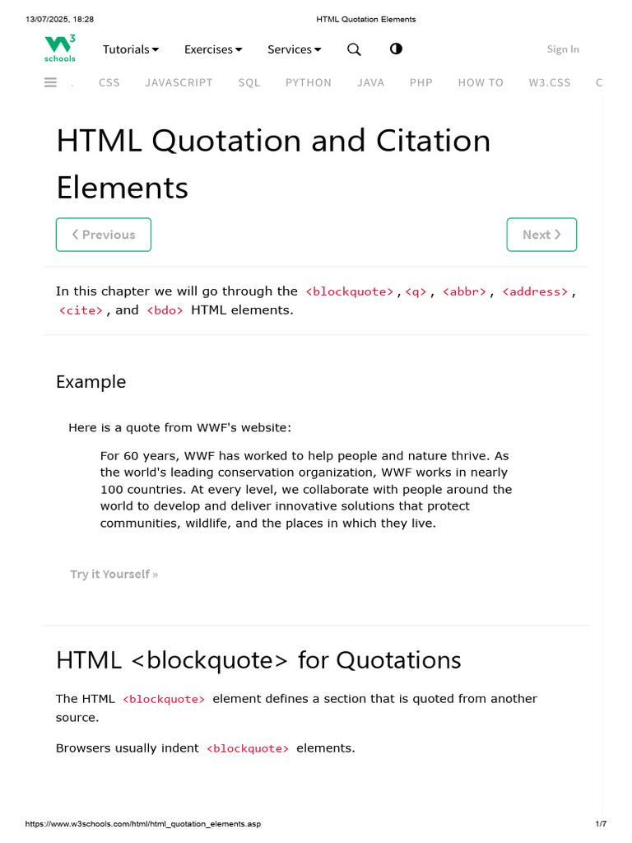
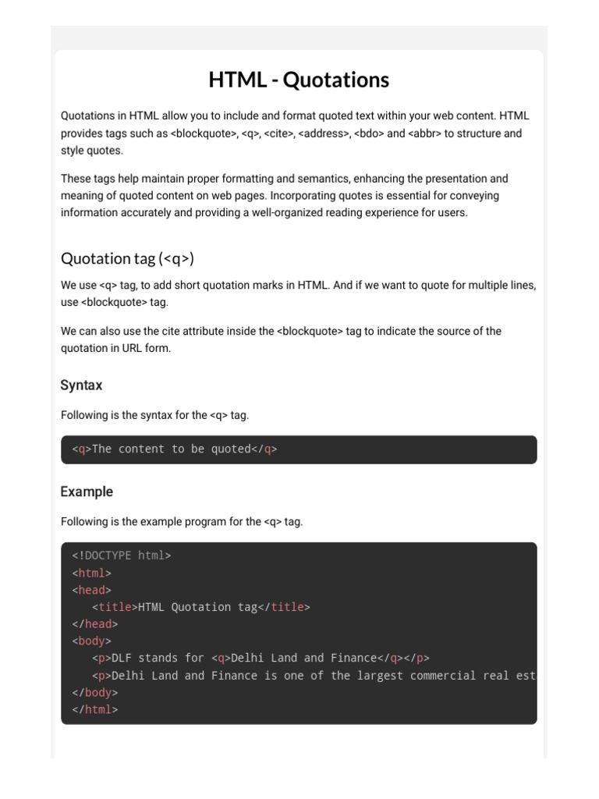
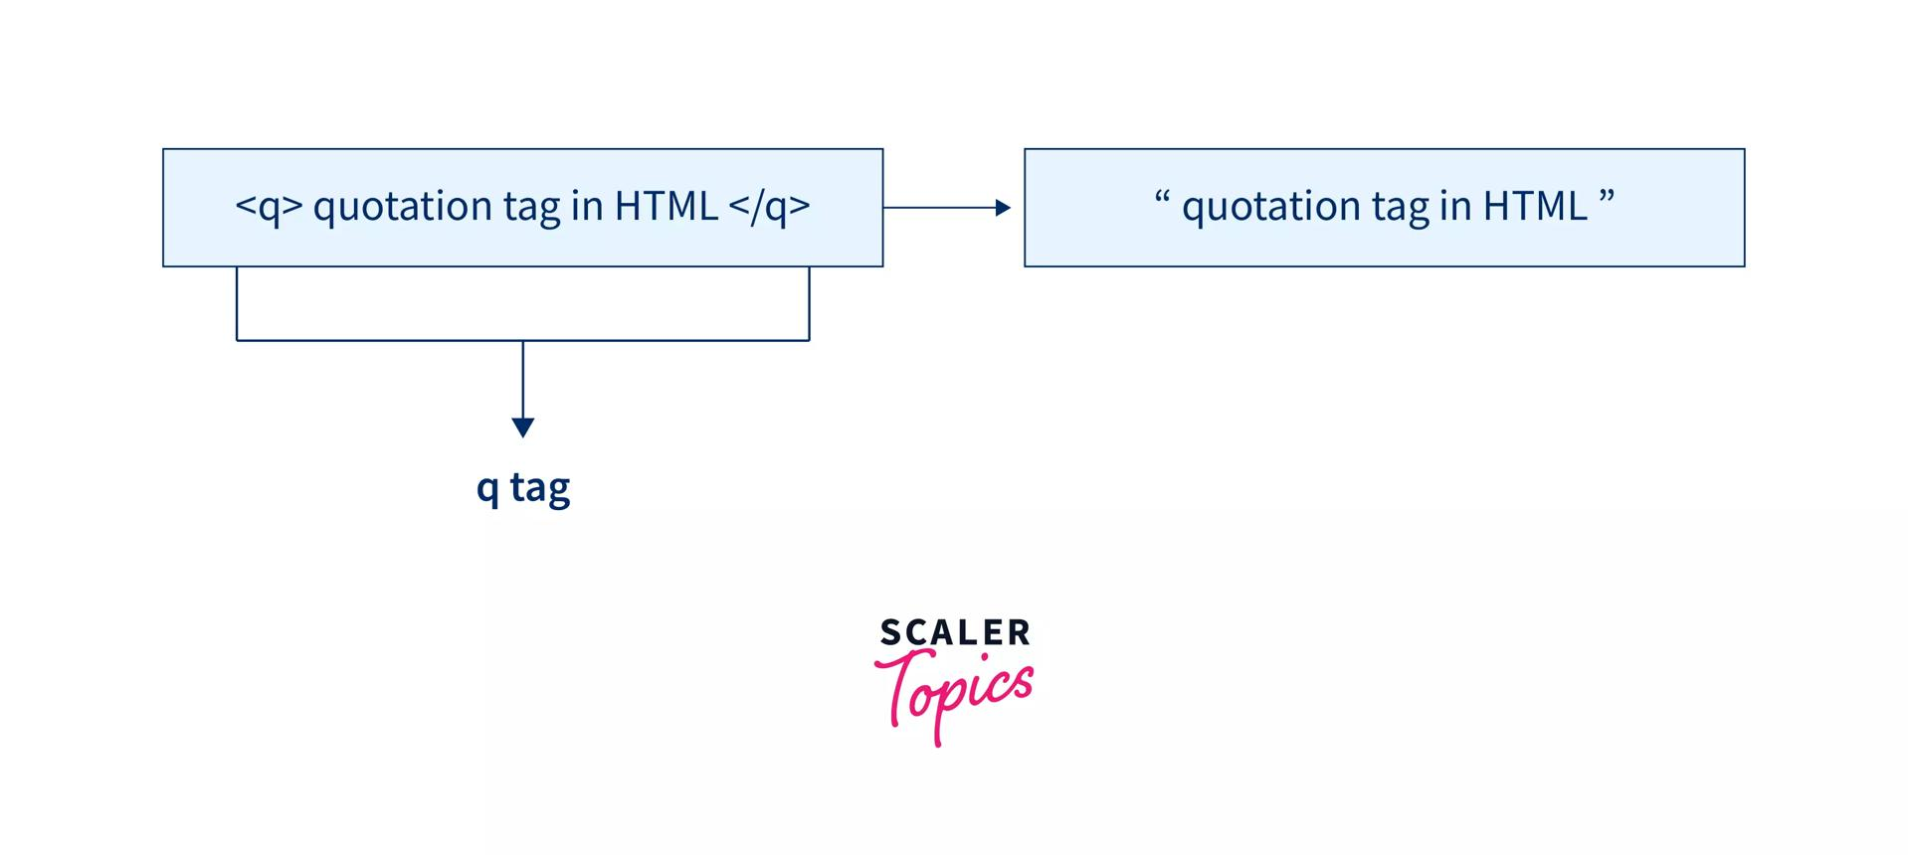

1. <blockquote> — Block Quote
# Source: AI Source: Provided by: [Data Path: Persons Table -> ID Column: 1, Name_En Column: Motasem Essam] -> From: [ChatGPT] on [5/6/2026]
📖 Description
Used for long quotations from another source.
💻 Example:
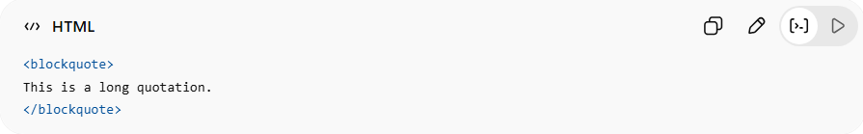
<blockquote>
This is a long quotation.
</blockquote>
👉 Usually displayed indented

2. <q> — Short Inline Quote
# Source: AI Source: Provided by: [Data Path: Persons Table -> ID Column: 1, Name_En Column: Motasem Essam] -> From: [ChatGPT] on [5/6/2026]
📖 Description
Used for short inline quotations.
💻 Example:
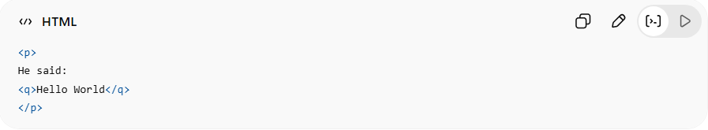
<p>
He said:
<q>Hello World</q>
</p>
👉 Browser automatically adds quotation marks

3. <cite> — Citation
# Source: AI Source: Provided by: [Data Path: Persons Table -> ID Column: 1, Name_En Column: Motasem Essam] -> From: [ChatGPT] on [5/6/2026]
📖 Description
Represents the title of a creative work:
- book
- movie
- painting
- website
💻 Example:
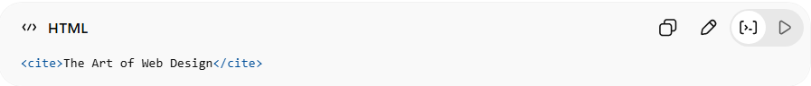
<cite>The Art of Web Design</cite>
👉 Usually displayed in italic

4. <abbr> — Abbreviation
# Source: AI Source: Provided by: [Data Path: Persons Table -> ID Column: 1, Name_En Column: Motasem Essam] -> From: [ChatGPT] on [5/6/2026]
📖 Description
Defines abbreviations or acronyms.
💻 Example:
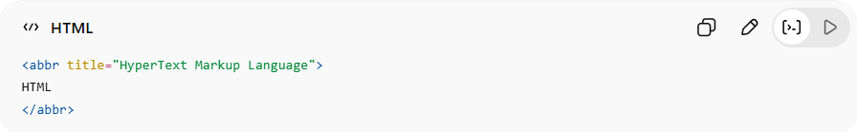
<abbr title="HyperText Markup Language">
HTML
</abbr>
👉 Tooltip appears on hover

5. <address> — Contact Information
# Source: AI Source: Provided by: [Data Path: Persons Table -> ID Column: 1, Name_En Column: Motasem Essam] -> From: [ChatGPT] on [5/6/2026]
📖 Description
Represents contact details for a person or organization.
💻 Example:
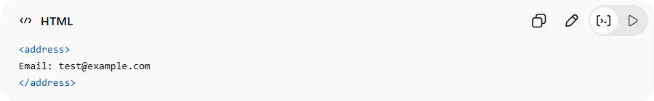
<address>
Email: test@example.com
</address>
👉 Usually displayed in italic

6. <bdo> — Bidirectional Override
# Source: AI Source: Provided by: [Data Path: Persons Table -> ID Column: 1, Name_En Column: Motasem Essam] -> From: [ChatGPT] on [5/6/2026]
📖 Description
Changes text direction.
💻 Example:
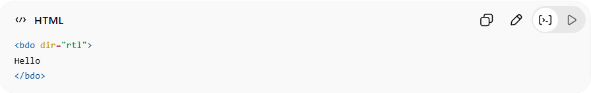
<bdo dir="rtl">
Hello
</bdo>
👉 Displays text from right to left

💻 Example

Full Example
# Source: AI Source: Provided by: [Data Path: Persons Table -> ID Column: 1, Name_En Column: Motasem Essam] -> From: [ChatGPT] on [5/6/2026]
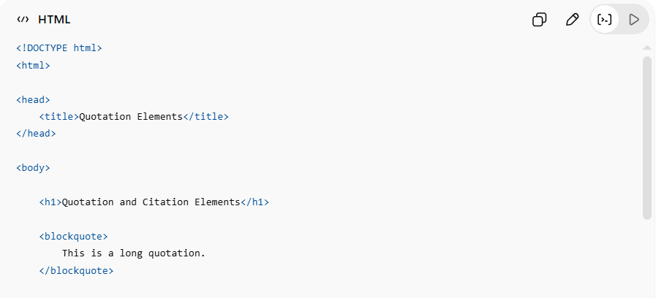
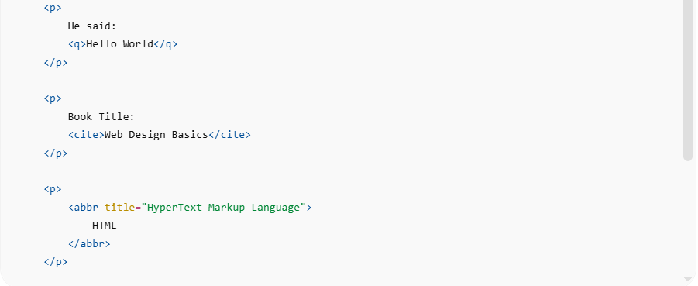
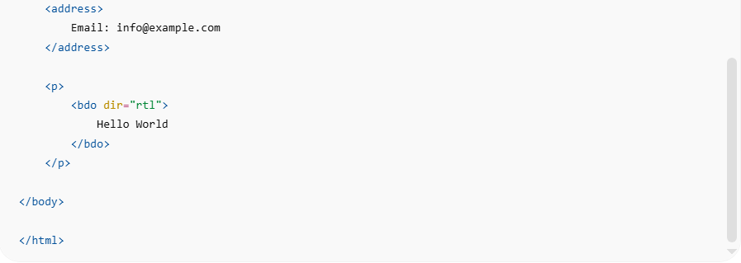
<!DOCTYPE html>
<html>
<head>
<title>Quotation Elements</title>
</head>
<body>
<h1>Quotation and Citation Elements</h1>
<blockquote>
This is a long quotation.
</blockquote>
<p>
He said:
<q>Hello World</q>
</p>
<p>
Book Title:
<cite>Web Design Basics</cite>
</p>
<p>
<abbr title="HyperText Markup Language">
HTML
</abbr>
</p>
<address>
Email: info@example.com
</address>
<p>
<bdo dir="rtl">
Hello World
</bdo>
</p>
</body>
</html>

Real Example
# Source: ScreenShot Source: Provided by: [Persons Table -> ID Column: 1, Name_En Column: Motasem Essam] -> Tool: [Automation Table -> ID Column: 16, Name_En Column: Screen Capture] -> From [Operating System: Windows] on [5/6/2026]
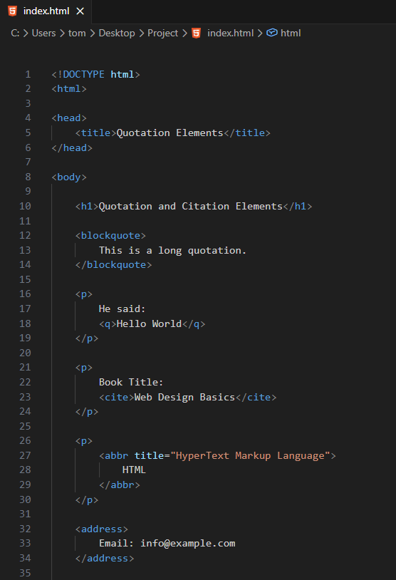
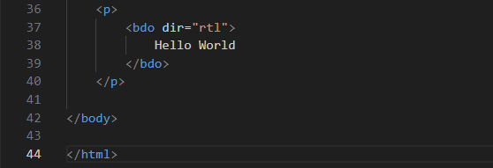
<!DOCTYPE html>
<html>

<head>
<title>Quotation Elements</title>
</head>

<body>

<h1>Quotation and Citation Elements</h1>

<blockquote>
This is a long quotation.
</blockquote>

<p>
He said:
<q>Hello World</q>
</p>

<p>
Book Title:
<cite>Web Design Basics</cite>
</p>

<p>
<abbr title="HyperText Markup Language">
HTML
</abbr>
</p>

<address>
Email: info@example.com
</address>

<p>
<bdo dir="rtl">
Hello World
</bdo>
</p>

</body>

</html>
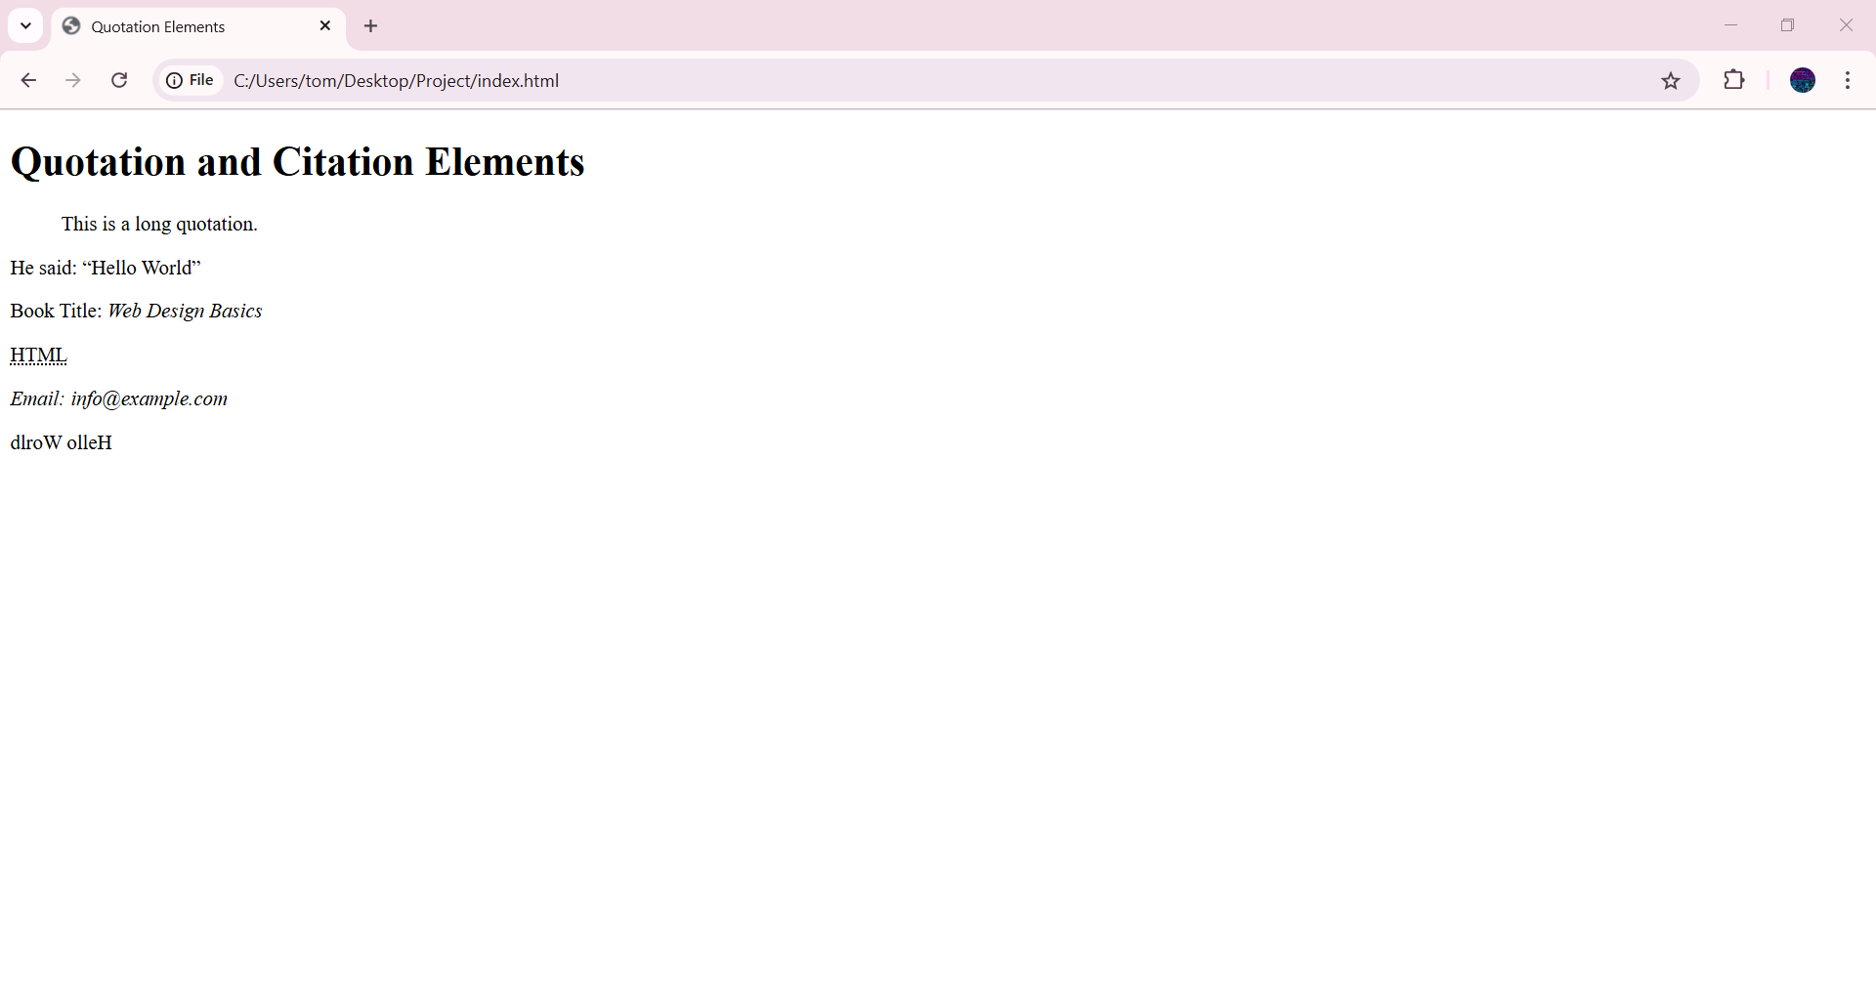

⚖️ Quick Comparison
# Source: AI Source: Provided by: [Data Path: Persons Table -> ID Column: 1, Name_En Column: Motasem Essam] -> From: [ChatGPT] on [5/6/2026]
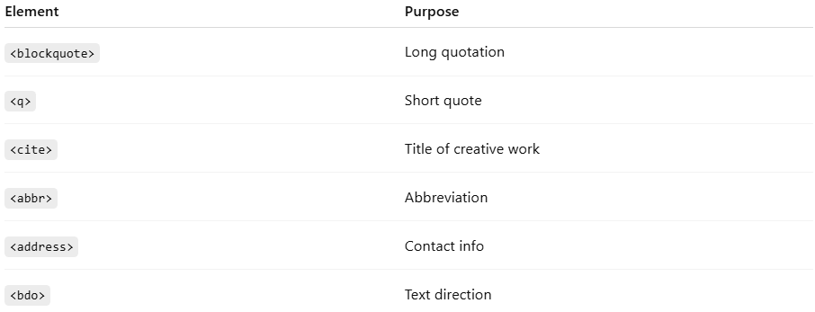
Element | Purpose
<blockquote> | Long quotation
<q> | Short quote
<cite> | Title of creative work
<abbr> | Abbreviation
<address> | Contact info
<bdo> | Text direction

🚀 In short:
# Source: AI Source: Provided by: [Data Path: Persons Table -> ID Column: 1, Name_En Column: Motasem Essam] -> From: [ChatGPT] on [5/6/2026]
HTML quotation and citation elements are semantic elements used to represent quotes, references, abbreviations, and contact information.

